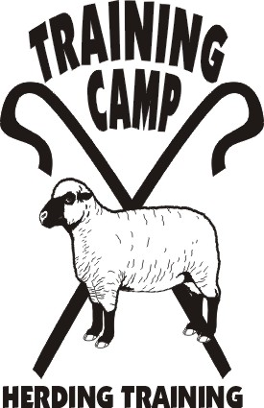

FUN DAY
LIVESTOCK AGILITY
Time & Points Trial

April 13, 2013

Seaman Farm

10 am to 3 pm
Limit 25
Cost $10/run
7 minutes – sheep
4 minutes - ducks

Agility course offered for sheep and ducks – jumps, weaves, tunnel, & table – points per obstacle
Level I – no handler line – Levels II & III – handler lines

You may run your dog, use the course or the field, and not participate in the agility.

PRE-REGISTRATION – send information to e-mail address joannay@aol.com
To aid with livestock and scheduling

FUN RUNS
Dog __________ Level ________ Stock______________

Name: _______________________________________________

