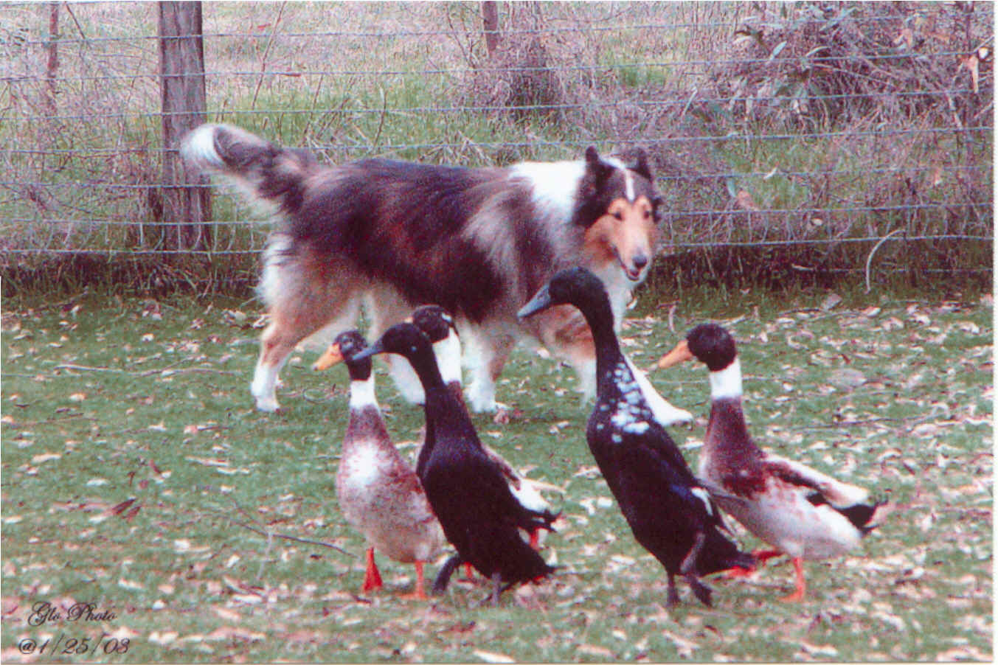
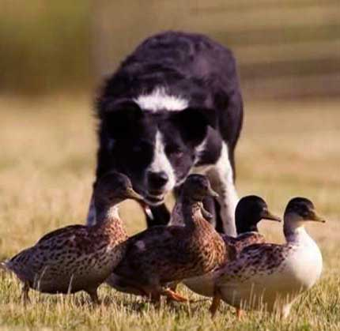
GREAT RIVER STOCK DOG CLUB

WINTER FUNDRAISER
2 AHBA DUCK TRIALS
Course #1

January 21, 2012

Leatherdale Equine Center Arena
University of Minnesota

Entries limited to 20 per trial

AM trial judge: Susane Hoffman
Start 8 am
PM trial judge: Joanna Yund
Start 1 pm

Entry Fee: $30/run

Potluck lunch & GRSC Annual Meeting
Approx. 11:30 am

Cure the winter blues with fun winter herding
in an indoor arena!

More information contact:
Audrey Jellison– kundegon@yahoo.com
Entry forms available at
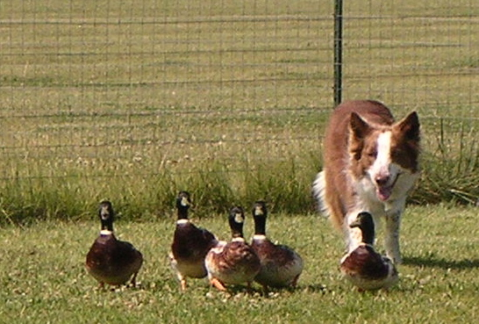
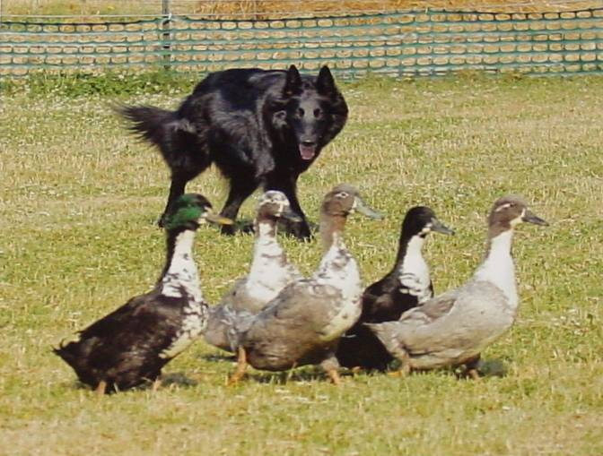
www.grsc.webs.com

