Premium List

GREAT RIVER STOCKDOG CLUB OF MINNESOTA
(Licensed by The American Kennel Cub)

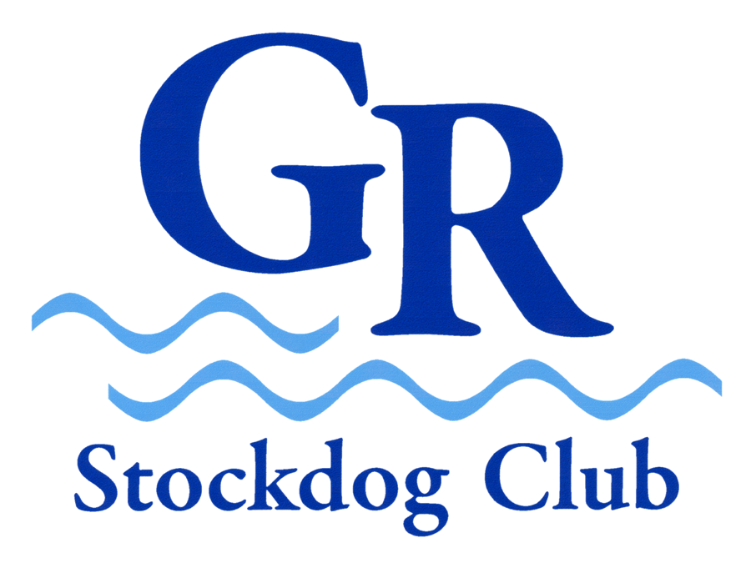
Herding Tests & Trials
Lawrence Farm, 11190 Ibson Ave, Northfield, MN 55057
This event will be held outdoors. Open to all AKC registered Herding Breeds
9 months of age and older, plus all other breeds allowed in the AKC Herding
Program and dogs granted an ILP, PAL or FSS number of these breeds.

2 TESTS 2 DUCK TRIALS 2 SHEEP TRIALS
Sheep or Goats will be used in test classes
_________________________________________________________
Saturday, June 23, 2012 Sunday, June 24, 2012
Event #2012480802 Event #2012480803
Course A & B Sheep Trials Course A & B Sheep Trials
Course B Outruns - 150 ft. Started - 300 ft. Intermediate - 350 ft. Advanced
_________________________________________________________

Event #2012480801 Event #2012480804
HT & PT Herding Tests HT & PT Herding Tests
Course A & B Duck Trials Course A & B Duck Trials
Course B Outruns - 60 ft. Started - 75 ft. Intermediate - 100 ft. Advanced
______________________________________________________________

ENTRY LIMITS EACH DAY
15 Test runs 30 Duck runs 45 Sheep runs
FEO runs accepted. See Notice to Exhibitor page.

ENTRIES CLOSE: Wednesday, June 6, 2012, 5:00 pm CDT,
or when limits are reached, after which time entries cannot be accepted,
cancelled, altered or substituted. When limits are reached, additional entries
will be placed on the Alternate's list. Drawing for running order will be held
9:00 am, Friday, June 8, 2012 at the Trial Secretary's home.

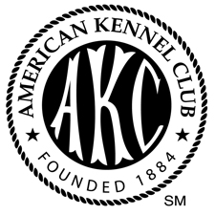 | American Kennel Club Certification  The American Kennel Club grants permission for the holding of these events under The American Kennel Club Rules and Regulations.  James P. Crowley, Secretary

Event #'s 2012480801, 02, 03, 04
GREAT RIVER STOCKDOG CLUB OF MINNESOTA - OFFICERS
President joannay@aol.com JoAnna Yund
Vice President lindaspang@msn.com Linda Spengler
Treasurer foxx17@aol.com Mary Steinbauer
Secretary intermodaires@yahoo.com Jim Mihalek
8609 White Oak Rd., St. Cloud, MN 56301

TEST/TRIAL COMMITTEE
Chairperson 11190 Ibson Ave, Northfield, MN 55057 Guy Lawrence
cowdogz@northfieldwifi.com
Julie Lawrence, JoAnna Yund, Mary Steinbauer, Linda Spengler,
Karen Gaffney, Julia Torgersen

TEST/TRIAL SECRETARY Conny Bouten
8900 Southwood Drive, Bloomington, MN 55437
RCBouten@MSN.com

JUDGES
Jan Wesen 7210 Worline Rd, Bow, WA 98232 17565
Carol Lucero 550 Paden St, Ft Lupton, CO 80621 ZD585
________________________________________________________
HT & PT plus A & B DUCK TRIALS A & B SHEEP TRIALS
Saturday Jan Wesen Carol Lucero
Sunday Carol Lucero Jan Wesen________

B COURSE TRIAL FIELD IS LOCATED 1 MILE FROM THE LISTED TRIAL SITE
It is a pasture with trees and perimeter fence.

FEE: $40.00 per dog per class. Make checks payable to GRSC
Exhibition Only runs $25.00 (See Notice To Exhibitor page for rules.)

LIVESTOCK
Sheep (Border Cheviot & crosses, White-faced crosses)
3 head per run A Course - 5 head per run B Course Value: $200 per head
Ducks (Khaki Campbell type drakes)
5 head per run A & B Course Value: $50 per head

Veterinarian (on call) Countryside Animal Hospital Dr. Rich Lorang, DVM
708 Schilling Dr N, Dundas, MN 55019 507-645-4522

Directions: From Trial site, turn left onto Ibson for 500 yards. Turn left (west) onto CR 81 (110th) and follow to State Hwy 3 (approx 2.5 miles). Turn Right (North) onto State Hwy 3 and follow for 2 miles. Turn Left (west) onto CR19 and follow for 3 miles to Eaves Ave. Turn Right (north) onto Eaves Ave and follow to North Ave. Turn Right (east) on North Ave and turn Left to Hospital.

RIBBONS & ROSETTES
First Place Blue Ribbon
Second Place Red Ribbon
Third Place Yellow Ribbon
Fourth Place White Ribbon
Fifth Place Pink Ribbon
Qualifying Score Dark Green Ribbon
High in Trial Blue, Red, Yellow Rosette
Reserve High in Trial Red, Yellow, White Rosette
_________________________________________________________________

MOTELS
Please contact the individual motels to verify size and number of
dog limits or any pet deposits or fees that may be required.

Americinn of Faribault 1801 Lavender Dr., Faribault, MN
(507) 334-9464
Best Western Saratoga Inn 31591 64th Ave, Cannon Fallsl, MN
(507) 263-7272
Faribault Days Inn & Suites 1920 Cardinal Lane, Faribault, MN
(507) 334-6835
Select Inn of Faribault 4040 Hwy. 60 W, Faribault, MN
(507) 334-2051
Super 8 Motel - Northfield 1420 Riverview Dr., Northfield, MN
(507) 663-0371

.
DIRECTIONS TO TRIAL SITE

From interstate 35, take exit 69 (Northfield; New Prague).
Go East on Minnesota 19 (Lonsdale Boulevard) about 7 miles.
Turn right (South) on Minnesota 3 (Dahomey Ave.) and go about
2.5 miles. Turn left (East) on Cnty Road 1 (110th St. East) about
0.5 miles to stop sign. Go straight (East) through stop sign on
Cnty Road 81 (110th St. East). Turn right (South) on Ibson Ave.,
and go about 0.2 miles to trial site on right.

There will BE DELICIOUS hot food provided by Almen’s Lunch Wagon

CATALOGS
Printed catalogs will be available by preorder with your entry – price $3.00
Run order sheets will be provided with your armbands. A complete marked catalog will be digitally sent to you after the trial.

NOTICE TO EXHIBITORS
Trial site available 7am to one hour after conclusion of events.
Exhibitors must have proof of rabies vaccine available (MN law).
Food will be available on site.
Parking in big field - no shade. Cooling tub provided.
Bitches in season will run in catalog order in Trial classes.
Please notify Trial Secretary if your bitch is in season.
American Kennel Club Rules regarding Conduct strictly enforced.
________________________________________________________
A SEPARATE ENTRY FORM FOR EACH LEVEL MUST BE
COMPLETED FOR EACH DOG ENTERED.
PLEASE FILL OUT ENTRY FORM LEGIBLY AND COMPLETELY.
HAVE AGREEMENT ATTACHED ALSO.
There will be no refunds for duplicate entries or errors on entry forms.
_________________________________________________________

FOR EXHIBITION ONLY
Dogs will run at the very end of the class entered. No dog can run FEO
in the same class it is entered for competition. Competition runs
will take priority over FEO runs. FEE is $25.00/same closing date.
_________________________________________________________

RETURNED CHECKS do not constitute a valid entry. No conditional or
phone entries will be accepted. Entry forms will not be accepted
without Fees or Signature. Entries not on official AKC forms or photo-
copies of entry forms without the Agreement and Rules on the reverse
side are not acceptable. Changes, additions or corrections to entry
forms must be received in writing prior to closing of entries.
ENTRY FEES SHALL NOT BE REFUNDED in the event that a dog is
absent, not allowed to compete in the entered class, disqualified,
excused by Judge, or barred from competition by action of the Trial
Committee. If because of riots, civil disturbances or other acts beyond
the control of the management it is impossible to open or complete the
trial, no refund of entry fee will be made.
THERE WILL BE NO REFUND, AFTER CLOSING DATE, OF ANY DOG
ACCEPTED IN THE TRIAL IF NO ALTERNATE IS AVAILABLE.
Refunds will be given to alternates unable to run.
__________________________________________________________
All fees to be in U.S. funds. Make checks payable to GRSC.
Mail entries with fees to: Conny Bouten, Trial Secretary
8900 Southwood Dr., Bloomington, MN 55437

OFFICIAL AMERICAN KENNEL CLUB ENTRY FORM ___________
GREAT RIVER STOCKDOG CLUB OF MINNESOTA
Herding Tests & Trials A & B Course Sheep and Ducks
Event #s 2012480801, 2012480802, 2012480803, 2012480804
Saturday, June 23, 2012 Sunday, June 24, 2012
Lawrence Farm 11190 Ibson Ave, Northfield, MN 55057

ENTRIES CLOSE...5PM CDT - Wednesday, June 6, 2012
Fee: $40.00 - FEO $25.00 per run. Checks Payable to GRSC.
Mail to: Conny Bouten, 8900 Southwood Dr, Bloomington, MN 55437

Conditional, unsigned, incomplete, telephone, fax or entries received without fees will not be accepted. Express mail deliveries must have signature waiver. All cancellations must be written and received by Trial Secretary by closing date.
I ENCLOSE $__________ for entry fees.
.__________________________________________________________________________
Tests Trials A Sheep B Sheep A Ducks B Ducks
Sat. Sun. Sat Sun Sat Sun Sat Sun Sat. Sun.
HT ( ) ( ) Started ( ) ( ) ( ) ( ) ( ) ( ) ( ) ( ) ( )
PT ( ) ( ) Intermediate ( ) ( ) ( ) ( ) ( ) ( ) ( ) ( ) ( )
Advanced ( ) ( ) ( ) ( ) ( ) ( ) ( ) ( ) ( )
__________________________________________________________________________
( ) AKC REG. NO. DATE OF BIRTH:
( ) AKC LITTER NO.
( ) ILP/FSS/PAL NO PLACE OF BIRTH ( ) USA ( ) Canada ( ) Foreign
( ) FOREIGN REG. NO. & COUNTRY ______ (Do not print in catalog)

BREED VARIETY SEX
FULL NAME
OF DOG_____________________________________________________________

BREEDER_____________________________________________________________

SIRE_______________________________________________________________

DAM _______________________________________________________________

ACTUAL OWNERS_____________________________________________________

OWNER'S ADDRESS __________________________________________________
CITY________________________________________STATE________ZIP________
Name of Owner’s Agent/HANDLER at Trial_____________________
I certify that I am the actual owner of the dog, or that I am the duly authorized agent of the actual owner whose name I have entered above. In consideration of the acceptance of this entry, I (we) agree to abide by the rules and regulations of the American Kennel Club in effect at the time of this trial, and by any additional rules and regulations appearing in the premium list for this trial, and further agree to be bound by the "Agreement" printed on the reverse side of this entry form. I (We) certify and represent that the dog entered is not a hazard to persons or other dogs.
This entry is submitted for acceptance on the foregoing representation and agreement.
SIGNATURE of owner or his agent duly authorized to make this entry:

SIGNATURE___________________________________________

PHONE EMAIL ADDRESS _________________________

Single copies of the latest edition of the "Rules Applying to DOG SHOWS" and "Rules Applying to
REGISTRATION And DISCIPLINE" and "GENERAL REGULATIONS For HERDING TESTS &
HERDING TRIALS" may be obtained WITHOUT CHARGE from THE AMERICAN KENNEL CLUB,
5580 CENTERVIEW DRIVE, RALEIGH, NC 27606-9767
AGREEMENT
____________________________________________________________________________
I (we) acknowledge that the "Rules Applying to DOG SHOWS" and The "Rules Applying to REGISTRATION
And DISCIPLINE" and the "GENERAL REGULATIONS For HERDING TESTS & HERDING TRIALS"
have been made available to me (us) and that I (we) agree that the club holding the Herding Test or Trial
has the right to refuse this entry for cause which the club shall deem to be sufficient. In consideration
of the acceptance of this entry and of the holding of the Herding Test or Trial land of the opportunity
to have the dog tested or judged and to win prize money, ribbons, or trophies, I (we) agree to hold the club,
its members, directors, governors, officers, agents, superintendents, or show secretary and the owner or
lessor of the premises and any employees of the aforementioned parties harmless from any claim for loss
or injury which may be alleged to have been caused directly or indirectly to any person or thing by the act
of this dog while in or upon the Herding Test or Trial premises or grounds or near any entrance thereto,
and I (we) personally assume all responsibility and liability for any such claim for damage or injury to the
dog, whether such loss, disappearance, theft, damage or injury, be caused or alleged to be caused by the
negligence of the club or any of the parties aforementioned, or by the negligence of any other person,
or any other causes.

I (we) hereby assume the sole responsibility for and agree to indemnify and save the aforementioned
parties harmless from any and all loss and expense (including legal fees) by reason of the liability
imposed by law upon any of the aforementioned parties for damage because of bodily injuries,
including death at any time resulting there from, sustained by any person or persons, including myself
(ourselves) or on account of damage to property, arising out of or in consequence of my (our)
participation in this Herding Test or Trial, howsoever such injuries, death or damage to property may
be caused, and whether or not the same may have been caused or may be alleged to have been caused
by negligence of the aforementioned parties or any of their employees or agents, or any other persons.

I (we) will pay for any livestock injuries or replacement value in the event of death of any livestock by
my (our) dog. In case of any injury to any stock caused by the dog entered, I (we) will assume total
responsibility for any damage. I (we) agree to pay the full market value of the injured animal in case
of serious injury, or the veterinarian bill if the injury is slight.

