PLEASE PRINT CLEARLY! (make copies if testing multiple dogs)

This all breed Herding Instinct Test is a fundraiser for Minnesota Wisconsin Collie Rescue.
www.mwcr.org
Herding Instinct Test at 10 a.m., Saturday, June 28

Run-throughs will run simultaneously to the Instinct Test.
Rain or shine event. Cancelled only for heavy rain or lightning.

Before June 15
Cost per dog is $45 for instinct test
$30 per run through*

After June 15
Cost per dog is $50 for instinct test
$35 per run through*

*If your dog has not passed a herding instinct test at an MWCR sponsored test event, you must provide proof that your dog has passed an instinct test to be eligible for a run through.
This herding instinct test is open to the accepted breeds of the American Herding breed Association.

Full Dog Name:
Breed:

ILP number or other registration? (registration through AKC not required for this test)

Owner’s Name:
Address:
City/State/Zip:
Home Phone: Work Phone:
E-mail address:

I have enclosed $ _________ entry fee for Herding Instinct Test registration ($45 per dog). Checks made out to MWCR. *Dogs tested previously who did not pass are welcome to try again now that they have some experience on sheep!

My dog passed the instinct test previously. I would like to do a supervised run-through (non-judged) with my dog. *Run-throughs ONLY available to dogs who have passed their instinct test. I have enclosed $________ ($30 per dog).

Entries, payment and recording forms (for Herding Instinct Test) must be received by June 15. Waiver can be turned in at event if registering online at http://www.mwcr.org/upcoming.htm otherwise please snail mail it with your payment. Checks payable to MWCR or register online at: www.mwcr.org. Snail mail to: Andi Wulff, 3231 Taylor Street NE, Minneapolis, MN 55418.

*There is a limit to the number of dogs we may test, so entries will be considered on a first come, first served basis.

Questions? Contact Andi at: andilou33@yahoo.com or phone 612-706-3273.

SPECTATORS WELCOME!

Tentative Schedule
Celebration of Herding Breeds
Saturday, June 28

10 am Handler’s meeting for herding instinct test - may be earlier if there are many entries.

10:05 am Instinct testing and run throughs

11:30 am Herding demos

Noon – 12:30 pm lunch! BRING YOUR OWN

12:30 pm Herding demos

1 pm Instinct testing and run throughs

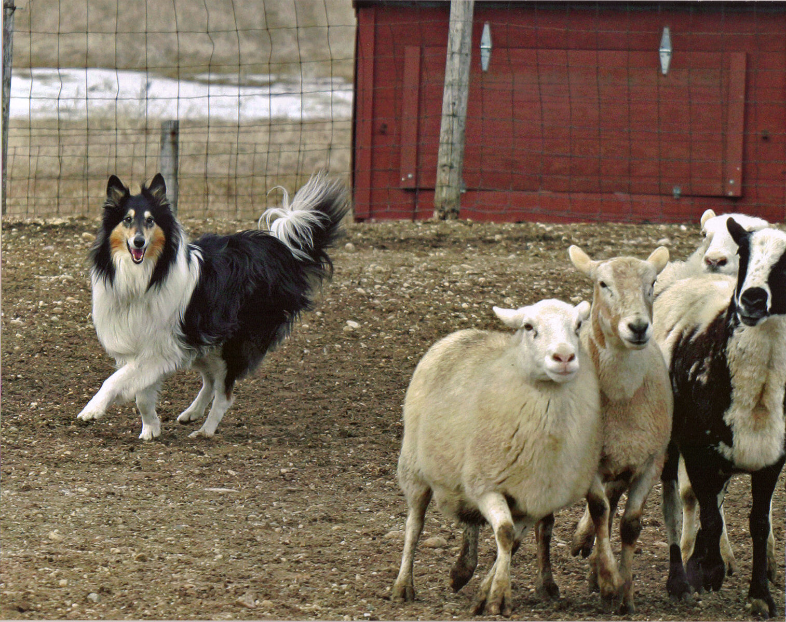

AGREEMENT -WAIVER

In consideration for participation in an event sanctioned by the American Herding Breed Association (AHBA) and held at JoAnna Yund’s, I (we) agree to assume all responsibility for any claim, loss or damage, of whatever kind or nature, whether to person or property, which may be caused at or near this event, either directly or indirectly, by me (us) or the dog(s) I (we) have entered in or brought to this event. I (we) further agree that I (we) will hold the AHBA, its officers, directors, agents and members and JoAnna Yund, MWCR, and their employees/help working this event, harmless and defend them from any and all liability for any injury, claim, damage or loss, of whatever kind or nature, whether to person or property, caused at or near this event. I (we) agree to indemnify the AHBA and MWCR, its officers, directors, agents or members and JoAnna Yund and associated persons, for any loss, cost or expenses, including attorney fees and costs, to which the AHBA, its officers, directors, agents or members and JoAnna Yund and associated persons might be subject as a result of any claim, suit, loss or damage caused in any way by any act or negligence on my (our) part or on the part of any dog(s) I (we) have entered in or brought to this event. I (we) acknowledge that while the AHBA may provide sanctioning for this event with regard to the issuing of titles, it and JoAnna Yund, MWCR and associated persons do not have and do not exercise control over the conduct of those present. I (we) certify and represent that the dog(s) I (we) have entered in or brought to this event is/are not a hazard to other dogs, other animals, or to people.

I (we) will pay for any livestock injuries or replacement value in the event of death of any livestock by my (our) dogs. In case on any injury to any stock caused by the dog(s) entered or said dog(s) actions thereof, I (we) will assume total responsibility for any damage. I (we) agree to pay the full market value, as set forth and noted in this event’s premium, of the injured animal in case of serious injury, or the veterinarian bill or its equivalent if the injury is slight.

Signature of entrant: X _________________________________________________________

AMERICAN HERDING BREED ASSOCIATION -- TEST RECORDING FORM
(please type or print clearly)

Breed: Reg. Name:
Registry & #: Sex:
Birthdate:
Sire: Dam:
Owner:
Breeder:
Owner's Address:

E-mail/Phone #:

SPONSOR: Minnesota Wisconsin Collie Rescue
DATE: June 28, 2008
LOCATION: Scandia, MN

CLASS (HCT/JHD): HCT STOCK TYPE: Sheep
TESTER: JoAnna Yund ENTRY #:

Q_____ NQ_____

To Myron Lindgren farm, Scandia, MN
*Scandia is NE of the Twin Cities metro area
Farm is on a ridge and if there is wind it is WINDY

From East/West Take Highway 36 to Highway 15 (Manning) -- go north to the third stop sign. This is Highway 4 (170th St.) Turn right (east) for 4.5 miles to Parade. Turn left on Parade, then left again on Old Marine Trail. The farm is on the east (right) side of the road; the driveway is next to the windbreak of trees.
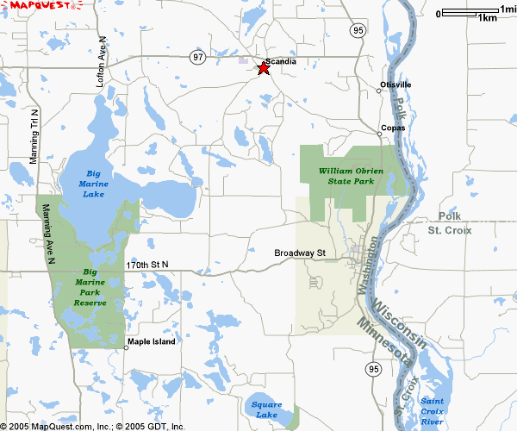
From North/South Take I-35 to Highway 97 and go east to Scandia (approx 15 miles). At Highway 52 (Oakhill) -- just past Scandia Elementary School -- turn right (south). Go approximately 1 mile to Oxboro; turn right (Oxboro only goes right). Pass Sand Lake to Old Marine Trail, turn left. The farm is on the east (left) side of the road; the driveway is next to the windbreak.
Myron Lindgren farm
Old Marine Trail
Marine on St.Croix Croix
(Hwy 4)

PERMISSION HAS BEEN GRANTED BY THE AMERICAN HERDING BREEDS ASSOCIATION (AHBA) TO HOLD THE TEST UNDER AHBA RULES AND REGULATIONS

NOTICE TO EXHIBITORS:
A separate entry blank for each dog entered. Please submit or bring with you a Test Recording form for each dog being tested. Test recording form not required for run throughs.

Notify event secretary of bitches in season.

Entry fee will not be refunded in the event that the dog is absent, disqualified, excused by a veterinarian or judge, or barred from competition by action of the host of the facility. Decision of management is final. Entry fees will not be refunded if the trial cannot open or be completed by reason of riot, civil disturbance, fire or act of God, public emergencies, act of public enemy, strike or any other cause beyond the control of the host. Dogs need only to be present for scheduled judging. Judges need not wait for any dog holding up the class. No unentered dogs (except set-out dogs) will be allowed at the trial site. All dogs must be kept on leash or kenneled except when being judged in the arena. Please bring your own chairs and additional shade.

This is a working facility and contains the normal hazards thereof. Children MUST be under adult supervision at ALL times.

