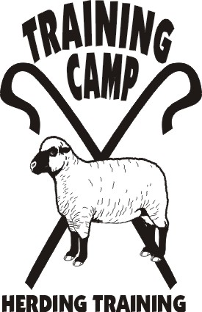
AHBA

and

AMERICAN HERDING
BREED ASSOCIATION

Are Pleased to Sanction and Sponsor

Herding Trial Dog (HTD) - Herding Trial Arena Dog (HTAD)

And Junior Herding Dog Test (JHD)

At Park Ridge Ranch, Mankato, MN
Approximately 8:30 am to 5:00 pm

Open to All Herding and Mixed Herding Breeds
(DOGS AT LEAST 9 MONTHS OF AGE)

TRIAL CLASSES: HTD I, II, III – Sheep - large open field with up to 500+ft outrun(III)
HTAD I, II, III – Sheep - Course 3 with take pen and ribbon pull(III)
TEST CLASS: JHD – Sheep

ENTRY LIMITS: 10 HTD – 15 HTAD – 5 JHD JUDGE: Tanya Wheeler
ENTRY FEES ALL CLASSES: TRIAL CHAIR: JoAnna Yund
PRE-ENTRY (Due June 30, 2012) $30/run JoAnnaY@aol.com
Day-Of (if livestock available) $40/run

- Handlers Meeting for HTD will be at 8:00 a.m. in the big field across the road
- Handlers Meeting for HTAD following HTD runs – appx 11:00 a.m.
- Handlers Meeting for JHD following HTAD runs - appx 2:00 p.m.
- Competitors are responsible for cleaning up after their dogs. All dogs must be on leash or crated when not competing.
- Competitors assume financial responsibility for medication and/or veterinary care and/or replacement value of stock for any injury caused by them or their dog(s).

Make-Your-Own Taco Bar Lunch and Beverages Available for Purchase

Directions to Park Ridge Ranch: Hwy 169/60 just South of Mankato, West (right) on MN-68 go 1.4 miles, left on CO-117 (547th Ave) go .2 miles, right on 211th Lane (gravel) about .25 miles to second left, follow signs. Mapquest address is 54521 Grouse Circle, Mankato MN (Do Not Google Map)

Camping is available onsite 7/3 and 7/4 - $10/night electric (limited) $5/night non-electric, indoor bathroom, shower and hospitality room available. Call Jennifer at 507-381-6684 to reserve in advance. Minneopa State Park Campground just 1 mile away with electric sites, non-electric sites and camper cabin. Make reservations early on DNR website.

Lodging in Mankato: See http://www.hotelplanner.com/Hotels/4961-Pet-Friendly-Hotels-in-Mankato-MN for Pet-Friendly Lodging.

Complete Entry Form and Trial/Test Recording Forms (one per run), make check payable to “Training Camp” and mail all to:
Jennifer Thompson; 54521 Grouse Circle; Mankato, MN 56001

NOTE: The September 2012 AHBA Trial with Nyle Sealine will have a SHED for HTAD III – Prepare!

